

Car Guy News

Volume 4, Issue 7 [www.tdcmotorclub.com](http://tdcmotorclub.com/favicon.ico) July, 2012

**President's Message**

Now is the time for all good cruisers to come to the aid of their club. The next week and a half will be a busy one. Between "Cruise for the Troops" on the 11th and "Drive Out Hunger" show on the 21st, it will prove to be an exciting and productive time.

As you know we have already surpassed cash donations of last years number by double, thanks to the generosity of Speciality Resources Corp. and Barb Shimer.

The first half of the year has been a great one between a terrific cruise season as well as a great Father's Day show.

And, we especially want to welcome all the new members who have joined our club.

The remainder of the year I'm sure will be just as exciting and an entertaining one and I do hope to see all of you at the "Drive Out Hunger" show on July 21st at the Downingtown High School. It should prove to be the best ever. We are expecting a very huge crowd and **I know we will have good weather.**

Cruise safely and enjoy yourselves.

Joe O"Fria, President

**Official Publication of the**

**Top Dead Center Motor Club**

PO BOX 173 Lionville PA 19353

Monthly General Meetings are held the **First Tuesday** of the month 7:00pm at Tom Oates Automotive in Chester Springs, PA

**Officers:**

**President: Joe O’Fria**

**Vice President: Dan Bourdon**

**Secretary: Frank Shimer**

**Treasurer: Joseph O’Fria III**

**Coordinators:**

**Membership: Denise Stoltzfus**

**Activities: Connie Robinson**

**Calendar: Harry Panson Webmaster: Jason O’Fria**

**Editor: Carolyn Hibbs**

**The Follow-up (Old Business)**

Click at the top of the page where you want the side-by-side columns to start, and press Enter twice. Click in the first paragraph mark on the page. On the Insert menu, click Text Box and drag on the page where you want the first column. Click Text Box again and then click and drag where you want the second column. Click in the last paragraph mark on the page, and press Ctrl + Enter to create a page break.

Repeat the process for each page that will contain side-by-side columns in your document and then return to the first text box you created. Click the text box on the left once to select it. Click your right mouse button and then click Create Text Box Link. The pointer becomes a pitcher. Click the text box on the left side of the second page to create a link. Create links for all text boxes within the same article on the left side of the document. Repeat the process for every text box in the right chain or article.

Pressing Enter twice at the top of each page will create an extra empty paragraph. This blank paragraph is useful if you want to insert text or graphics outside of the text boxes. You can delete the extra blank paragraph if you don't need it.

**The Details (New Business)**

You can copy an article or a chain of text boxes that are linked together, to another document or to another location in the same document. To copy linked text boxes and the text they contain, you must copy all the linked text boxes in an article. Select the first text box in an article. Hold down Shift, and click each additional text boxes you want to copy. On the Edit menu, click Copy. Click where you want to copy the text boxes and then click Paste.

Do not select the text box. You can paste text you’ve copied directly into your document, into another location within the same article, or into another article.❖

**Activities:**

|  |  |
| --- | --- |
| **TDC Motorclub New Web Page** | |
|  | **Visit our new web page @ TDCMotorclub.com**  Danielle would like to have a picture of each members car(s) with a blurb about you.  And don't forget to visit the web site to find up-to-date news of present and future events. |

|  |  |
| --- | --- |
|  | |
|  |  |
|  |  |
|  |  |
|  |  |
|  |  |

**Those members who still need windshield card(s) for their vehicles, please reply to the email sent on May 4th by May 18th with the following:**

1. owner ofeach vehicle

2. year and make of each vehicle for which a card is needed.

These are put in the windshield on display to identify our club when we go to cruise events.

**Support The Troops**

**TDC Monthly Cruise nights- Second wednesday of the month April thru September at the VFW on Business Route 30 just oustside of Downingtown. We will have ample room to display cars on the large lawn and spectator parking in the rear.**

**(Flyer Attached)**

**50/50 and Door Prizes**

**We will be having Cruise Night Rain Dates in 2012.**

**The rain date will be the following Wednesday after the original date.**

**Volunteers needed for parking and donation collection.**

\*\*There was a great turnout at our first "Cruise for the Troops" despite the rain/sleet. Forty plus cars were in attendance.

**The Community Courier will be doing an article on TDC Motor Club and the "Cruise for the Troops".**

***INDEPENDENCE DAY PARADE***

**July 4, 2012**

**If you plan on being in the parade please email me at Carolyn@tdcmotorclub.com**

***by May 25th*.**

**There is information I need as soon as possible that I have to send to the**

**City of Philadelphia by June 1st.**

**Thanks, Carolyn**

**WINDSHIELD CARDS**

Those members who still need windshield card(s)

**THE FOLLOW-UP/THE HAPPENINGS**

**Treasury Report:**

Watch your email for a copy of the Treasurer’s

Report – coming soon! ~*Joseph O’Fria, Treasurer*

**\*\*HAPPENINGS\*\***

**Drive Out Hunger**

***\*\*\*PRE-REGISTERING***\*\*\*

You can now pre-register on the web page for this event, but will still need to send payments or bring with you the day of the show. We will email confirmation letters/emails to everyone that pre-registers. Participants must bring their confirmations with them the day of the event.

A list of the pre-registrants will be generated for the "Welcome" and "Registration" tents.

We are still in need of volunteers. Please keep in mind that this a TDC sponsored event, our biggest fund raiser of the year, and therefore it is a working show. We need as much help that you can provide the day of the show.

We have a donation request letter available for those who may need it to obtain donations or door prizes from businesses. We can email a copy to you.

If you have donations or door prizes, they can be dropped off at the O'Fria's on Thursday evening the 19th or Friday evening the 20th.

If you have supplies related to the show such as tents, cash boxes, etc. please drop them off at our trailer which will be parked at the O'fria's during the same time, Thursday or Friday night.

for their vehicles, please contact Joseph@tdcmotorclub.

1. You need to supply the name of the owner of the car

2. Year, make and model of each car

These are to put in your windshield on display to identify

our club when we go to events.

**Independence Day Parade**

TDC Motor Club had twenty (20) cars in attendance for the

Philadelphia 4th of July Parade. Four (4) of our members

escorted Miss Philadelphia, Miss Teen Philadelphia and

selected teachers from Delaware and New Jersey.

As we entered Philadelphia some of our cars got separated

from the others due to the lack of communications among

the police authorities.

But, despite the heat, confusion and slow start of the parade,

we as a group, survived. We entertained the crowds with

reving engines, burnouts and queen waves.

**O'Fria's Car-B-Que**

Another sucessful 4th of July car-b-que was enjoyed by the

club members who accepted the invitation to the O'Fria's.

There were appetizers, covered dishes, a counter covered

with all kinds of deserts, drinks, games and just sitting

around bsing with each other.

I, and I am sure I speak for all who attended, want to thank

Joe and Gerry and family for a wonderful time on such a hot day.

I promise by next year I will sharpen my skills on "The Bean

Bag Toss" by not trying to hit the birds as they fly by and

instead aim for hole in the wood.

Carolyn Hibbs, aka Mona

**CAR MAGNETS**

The club members, who participated in the Philadelphia

4th of July Parade, were presented with club logo magnets

to display on the each side of our cars to signify our loyalty

to TDC Motor Club.

They really looked great as we drove up Chestnut and then

down Market Street. Heads turned as we wowed the crowd

with our many collections.

We have been given the oppurtunity to purchase these magnets

at the cost of $10.00 each.

**Activities/Shows:**

As a club we would like to participate in other activities, beside the normal show and cruise night schedule, we want to be able to gather socially and get to know one another and do something that doesn’t necessarily involve cars…but can involve spouses/significant others and family!

**TDC Tool Time:** If anyone is in need of a few helpings hands, let Harry Panson know at [harry@tdcmotorclub.com](mailto:harry@tdcmotorclub.com)

**Rob DeGrandis has a large warehouse facility located at 185 Lancaster Avenue in Malvern, PA for rent. It is secure and accessible six (6) days a week during business hours of DeGrandis Auto. Cost is $100.00 a month for members and $130.00 a month for non-members. Contact Rob or Tiffany @ 610-644-6990 or** [**degrandisauto@comcast.net**](mailto:degrandisauto@comcast.net)**. Four (4)**

**spots are still available.**

**\*\*ATTENTION\*\***

**Please email tdcmotorclub@gmail.com with your favorite shows for the season to "Cruise To"**

**as a group**

**Trailer Update**

One of our sponsors, Bull Dog Rod and Custom in West Chester, has finish the trailer to our specifications and even inspected it for us, free of charge.

**THANK YOU TO THE GUYS AT BULLDOG**

We would also like to thank the members who gave their time and elbow grease to get the trailer ready for this busy season.

**tentative 2012 calendar**

**July 11 Wed. Cruise Night 5pm VFW Dwtwn.**

**July 21 Sat. DOH Show 7am DEHS**

**July 28 Sat. DOH (rain date) DEHS**

**Aug. 7 Tues. Club Meeting 7pm Tom Oates**

**Aug. 8 Wed. Cruise Night 5pm VFW Dwtwn.**

**Sept. 4 Tues. Club Cruise 7pm Tom Oates**

**Sept 12 Wed. Cruise Night 5pm VFW Dwtwn.**

**Oct. 2 Tues. Club Meeting 7pm Tom Oates**

**Oct. 7 Sun. Club Picnic 12pm Bob & Pats**

**Oct. 27 Sat. Halloween Event Tom Oates**

**Oct. 28 Sun. Raindate Tom Oates**

**Nov. 6 Tues. Club Meeting 7pm Tom Oates**

**Dec. 1 Sat. Holiday Party 7pm TBA**

**Dec. 4 Tues. Club Meeting 7pm Tom Oates**

Check Out [www.tdcmotorclub.com](http://www.tdcmotorclub.com) for More Show information, Click on Event Calendar.

**SUPPORT OUR TROOPS**

TDC Monthly Cruise Night - Second Wednesday of the

month April thru September at the VFW on business

Route 30 just outside of Downingtown, PA. We will

have ample room to display cars on the large lawn and

spectator parking in the rear. There will be 50/50 and

door prizes.

The rain date will be the following Wednesday.

Volunteers are needed for parking and donation collection.

(flyer attached)

\*\*Due to the generous donations for our troops ,TDC has already sent out nine (9) packages to our men and women

in uniform.

***July Birthdays:*** ***New Members:***

**7/02 - Donald Sheldon 7/08 - Jim Lanahan Jim Charley**

**7/13 - John Luminella Elkin Jaramillo**

**7/14 - Cindy Gillespie Matthew Downs**

**7/16 - Gail Luminella Jack Steczak**

**7/21 - Jeannemarie Allshouse Dave Hatt**

**7/22 - Bob Stevens John Luminella, Jr.**

**7/28 - Connie Robinson Ron Pistone**

**7/28 - Traudi Stevens Donald Sheldon**

**Jim Lanahan**

**FUTURE DATES TO KEEP IN MIND**

**(All club sponsored dates are highlighted in bold print)**

**July 11th - "Cruise for the Troops". VFW Post 845 Downingtown - 5 PM until dusk**

July 15th - Media show sponsored by Delco Cruisers. 10 a.m. till 3p.m. $15.00 fee

**July 21st - "Drive Out Hunger" show.**

**July 28th - Rain Date for "Drive Out Hunger" show**

**Every Thursday, Chester Springs Creamery - TDC has a mini cruise night to the Milky Way Farm/Chester Springs**

**Creamery on Route 113 in Lionville, PA.**

Faulkner Cruise Night is held the second (2nd) of Friday during the season.

**Re-Cap**

***\*Mark your calendar –Our next meeting is Tuesday, August 7, 2012 at Tom Oates Automotive in Chester Springs, Pa. 7:00pm***

**CLASSIFIEDS**

If you have an item that you would like to sell or a specific item you are looking for you can submit it for the newsletter and

we’ll advertise it here! E-mail Jason O’Fria at [jason@tdcmotorclub.com](mailto:jason@tdcmotorclub.com) to add your item to the classified section.

YOUR AD HERE-Buy, Sell, Trade, Services, Want Ads –Please submit via club e-mail or PO BOX

Notary Public Service that comes to you: Joseph O’Fria 610-316-9349 [joe.ofria@gmail.com](mailto:joe.ofria@gmail.com)

*Design your own custom made NEON wall sign!* All signs are hand crafted, and mounted to a PVC backing, which can be hung in your den or garage. This would make a great collectors piece for any Auto Enthusiast. Signs varyinsize and price due to the colors and artwork. Prices start around $ 165.00. contact Bob Bodek at ( ***[RBodekNEON @aol.com](mailto:RBodekNEON%20@aol.com" \t "_blank)***) or call 484-881-2000.

**Sponsors**

Hudson Rod and Competition, Gilbertsville PA T.E. Snyder Fabricating, West Chester PA

Steve Giordanno [www.hudsonperformance.com](http://www.hudsonperformance.com) Tom Snyder [www.snyder-fab.com](http://www.snyder-fab.com)

* + 1. 610-429-0669

DeGrandis Automotive Center

Rob DeGrandis [www.degrandisautomotivecenter.com](http://www.degrandisautomotivecenter.com)

610-644-6990

Pennsylvania Promotions Inc, Lansdowne Tom Oates Automotive, Chester Springs,

Joe O’Fria [www.papromo.com](http://www.papromo.com) Tom Oates www.tomoatesautomotive.com

610-622-2800 610-827-7400

Eagle Investment Advisors- Downingtown YEP Graphix

Dave Summers- [www.eagleia.com](http://www.eagleia.com) Morgan Phillips- [www.yepgraphix.com](http://www.yepgraphix.com)

610-269-0269 [dsummers@eagleia.com](mailto:dsummers@eagleia.com) 215-990-5014 [mvphillips@gmail.com](mailto:mvphillips@gmail.com)

Centurion Motor Car BullDog Rod & Custom

Dave Besselman [www.centurianmotorcar.com](http://www.centurianmotorcar.com) [www.bulldogrodcustom.com](http://www.bulldogrodcustom.com)

610-637-5763 610-431-1970

WPAZ-Pottstown AM Radio Rob’s Rod Shop - Downingtown

Brian James Sales@RobsRodShop.com

484-693-0640

Streetside Auto.com Eagle Investment Agency

Trick Your Ride at Streetside 110 Hopewell Road Suite 210

Downingtown, PA 19335

610-269-0269

21st Century Insurance dsummers@eagleia.co,

**Think of our sponsors first when shopping for anything related to what they can provide. They support us, we should support them!...If you have a prospective sponsor, give them an application!**

**BIRTHDAY/ANNIERSARIES, ETC.**

February Birthday Wishes to:

Ronald J. Oliver – 2/3

James Saltzburg – 2/10Susan Hernandez – 2/28

*If you see or talk to any of these folks be sure to wish them a Happy One!*

*--------------------------------------****Communication Survey:***

*Would you like to receive a text alert from TDC when there is an upcoming event or meeting?*

*We’d like to know what you think, let us know the next time we see you!*

**Activities/Shows: Cont’**

**CRUISE NIGHTS 2012**

**“THIS BEARS REPEATING”**

**TDC Cruise Nights** to Support the Troops!

Chair/Contact: *Dan Bourdon* VP ([dan@tdcmotorclub.com](mailto:dan@tdcmotorclub.com))

**When:** Look for our next “Cruise For the Troops” next year. First cruise for 2012 is April 11th from 5:00pm to dusk…

**Where:** VFW in Downingtown, just outside of Downingtown on Business Route 30. We will have ample room to display cars on the large lawn and spectator parking in the rear!

* 50/50 and Door Prizes

**We will be having Cruise Night Rain Dates! The rain date will be the following Wednesday after the original date.**

**Newsletter Submissions:**

If you would like to contribute to the newsletter, with a point of interest, or a classified ad etc, please e-mail [tdcmotorclub@gmail.com](mailto:tdcmotorclub@gmail.com) with in one week after the current months meeting, for publication in that months newsletter.

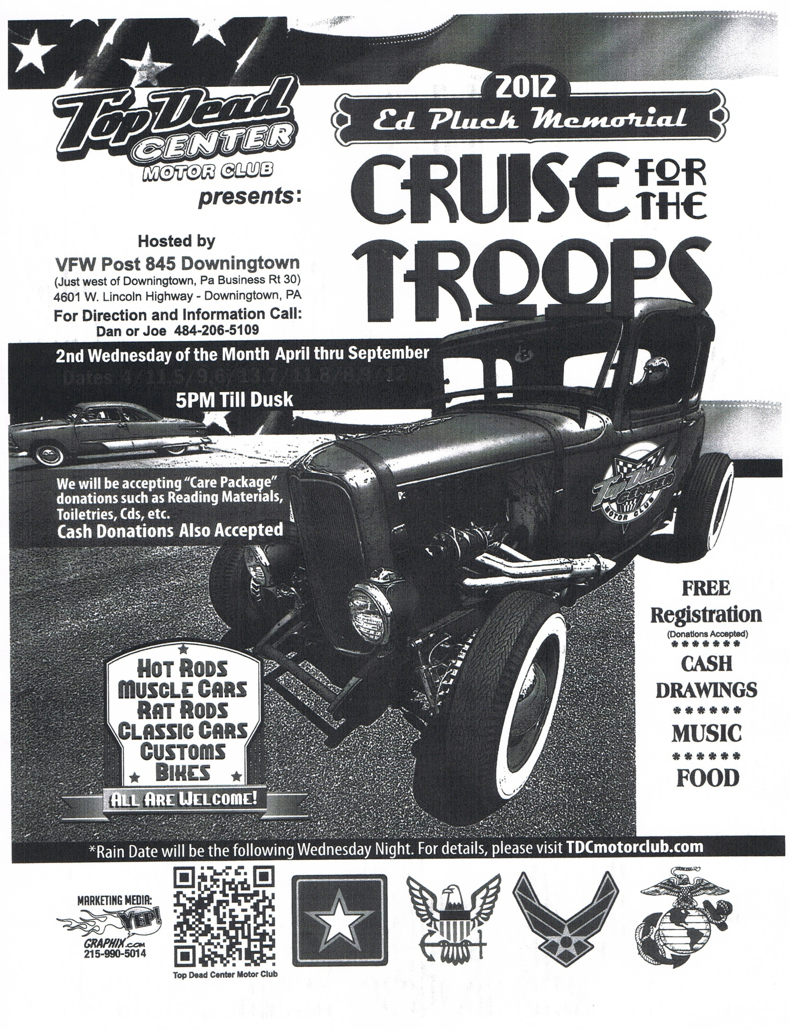

**Classifieds:**

If you have an item that you would like to sell, or a specific item you are looking for you can submit it for the newsletter and