

Car Guy News

Volume 4, Issue 8 [www.tdcmotorclub.com](http://tdcmotorclub.com/favicon.ico) August, 2012

**President's Message**

While our President and his family are on a well deserved vacation, he sends this message:

Thank you everyone for all of the help and support each and everyone provided for the 2012 "Drive Out Hunger Show".

There were 90 registered cars and 35 member cars.

For the West Chester County Food Bank we collected 2400 lbs. in food donations and $1300.00 in cash donations.

With less attendance than 2011, we collected more food and cash donations.

The show was a success even though people were fearful of the weather. In general it went well. No event is perfect, we cannot fairly compare last year to this year, as the weather played a role.

Barb will be sending thank you letters to all the companies and individuals who helped support the cause.

Now that the show is over, we will be placing the sportswear order since we have the minimum

amount needed. If you would like to purchase an item, please see the website for prices, order form, etc.

Joe O"Fria, President

**Official Publication of the**

**Top Dead Center Motor Club**

PO BOX 173 Lionville PA 19353

Monthly General Meetings are held the **First Tuesday** of the month 7:00pm at Tom Oates Automotive in Chester Springs, PA

**Officers:**

**President: Joe O’Fria**

**Vice President: Dan Bourdon**

**Secretary: Frank Shimer**

**Treasurer: Joseph O’Fria III**

**Coordinators:**

**Membership: Denise Stoltzfus**

**Activities: Connie Robinson**

**Calendar: Harry Panson Webmaster: Jason O’Fria**

**Editor: Carolyn Hibbs**

**The Follow-up (Old Business)**

Click at the top of the page where you want the side-by-side columns to start, and press Enter twice. Click in the first paragraph mark on the page. On the Insert menu, click Text Box and drag on the page where you want the first column. Click Text Box again and then click and drag where you want the second column. Click in the last paragraph mark on the page, and press Ctrl + Enter to create a page break.

Repeat the process for each page that will contain side-by-side columns in your document and then return to the first text box you created. Click the text box on the left once to select it. Click your right mouse button and then click Create Text Box Link. The pointer becomes a pitcher. Click the text box on the left side of the second page to create a link. Create links for all text boxes within the same article on the left side of the document. Repeat the process for every text box in the right chain or article.

Pressing Enter twice at the top of each page will create an extra empty paragraph. This blank paragraph is useful if you want to insert text or graphics outside of the text boxes. You can delete the extra blank paragraph if you don't need it.

**The Details (New Business)**

You can copy an article or a chain of text boxes that are linked together, to another document or to another location in the same document. To copy linked text boxes and the text they contain, you must copy all the linked text boxes in an article. Select the first text box in an article. Hold down Shift, and click each additional text boxes you want to copy. On the Edit menu, click Copy. Click where you want to copy the text boxes and then click Paste.

Do not select the text box. You can paste text you’ve copied directly into your document, into another location within the same article, or into another article.❖

**Activities:**

|  |  |
| --- | --- |
| **TDC Motorclub New Web Page** | |
|  | **Visit our new web page @ TDCMotorclub.com**  Danielle would like to have a picture of each members car(s) with a blurb about you.  And don't forget to visit the web site to find up-to-date news of present and future events. |

|  |  |
| --- | --- |
|  | |
|  |  |
|  |  |
|  |  |
|  |  |
|  |  |

**Those members who still need windshield card(s) for their vehicles, please reply to the email sent on May 4th by May 18th with the following:**

1. owner ofeach vehicle

2. year and make of each vehicle for which a card is needed.

These are put in the windshield on display to identify our club when we go to cruise events.

**Support The Troops**

**TDC Monthly Cruise nights- Second wednesday of the month April thru September at the VFW on Business Route 30 just oustside of Downingtown. We will have ample room to display cars on the large lawn and spectator parking in the rear.**

**(Flyer Attached)**

**50/50 and Door Prizes**

**We will be having Cruise Night Rain Dates in 2012.**

**The rain date will be the following Wednesday after the original date.**

**Volunteers needed for parking and donation collection.**

\*\*There was a great turnout at our first "Cruise for the Troops" despite the rain/sleet. Forty plus cars were in attendance.

**The Community Courier will be doing an article on TDC Motor Club and the "Cruise for the Troops".**

***INDEPENDENCE DAY PARADE***

**July 4, 2012**

**If you plan on being in the parade please email me at Carolyn@tdcmotorclub.com**

***by May 25th*.**

**There is information I need as soon as possible that I have to send to the**

**City of Philadelphia by June 1st.**

**Thanks, Carolyn**

**WINDSHIELD CARDS**

Those members who still need windshield card(s)

**THE FOLLOW-UP/THE HAPPENINGS**

**Treasury Report:**

Watch your email for a copy of the Treasurer’s

Report – coming soon! ~*Joseph O’Fria, Treasurer*

**\*\*HAPPENINGS\*\***

"ELECTION YEAR"

This year is an election year for the officer positions. We will be accepting nominations through the October meeting.

You can send your nominations via email or usps to the secretary. Email: secretary@tdcmotorclub.com. or

USPS: Top Dead Center Motor Club P.O. Box 173

Lionville, PA 19353.

The voting will take place at out November meeting, which happens to be National Election Day.

Officers serve a two (2) year term.

**SEPTEMBER MEETING**

September 4th meeting will be held at Ron's Bar on Route 113. The meeting will start at 7:30pm to give everyone a chance to eat. Those of our members who have eaten there say the food is delish!! So come early and enjoy, if you wish. They will have a separate room for us. Ron's Bar will be donating 15% of our meals to the CLUB!! (minus drinks)

**CHRISTMAS STOCKINGS**

**FOR THE TROOPS**

With the help of Caryn Abdill, I am trying to make at least 100 stockings for the troops.

We decided at the August meeting it was better to fill them with individual snack items rather than trial size toiletries.

These are going to have to be sent out by the end of November so as to get to Afghanistan by the holidays.

Thank you to all the TDC elves for your donations. Carolyn, aka Mona

for their vehicles, please contact Joseph@tdcmotorclub.

1. You need to supply the name of the owner of the car

2. Year, make and model of each car

These are to put in your windshield on display to identify

our club when we go to events.

**CAR MAGNETS**

The club members, who participated in the Philadelphia

4th of July Parade, were presented with club logo magnets

to display on the each side of our cars to signify our loyalty

to TDC Motor Club.

They really looked great as we drove up Chestnut and then

down Market Street. Heads turned as we wowed the crowd

with our many collections.

We have been given the oppurtunity to purchase these magnets

at the cost of $10.00 each.

**WILDWOOD WEEKEND**

**September 20-23, 2012** - If you are interested in going to the

Boardwalk Classic Car Show in Wildwood, NJ, please ***CALL***

Gerry O'Ofria at 610-389-0919 for hotel registration...we stay

at the Singapore Motel in Wildwood Crest $90.00/per 1 to 3 nights.

To pre-register for the show please visit www.thundermoto.com,

fill in the registration form. Make sure to choose LOAD on

Leaming Ave as 1st choice and make sure you put that you are

with Top Dead Center Motor Club, $50.00 fee. Some will leave

Thursday around noon if you would like to go with that group.

**MORE INFO TO FOLLOW**

***HELP!!!!!***

**Ernie's son, Tyler, will be coming home from Afghanistan**

**in approximately 75 days. He is asking our help to set up**

**a tool time to work on Tyler's car. Ernie is trying to**

**surprise his son and have it running by the time Tyler**

**gets home.**

**Hopefully, we can accommodate his request.**

**Activities/Shows:**

As a club we would like to participate in other activities, beside the normal show and cruise night schedule, we want to be able to gather socially and get to know one another and do something that doesn’t necessarily involve cars…but can involve spouses/significant others and family!

**TDC Tool Time:** If anyone is in need of a few helpings hands, let Harry Panson know at [harry@tdcmotorclub.com](mailto:harry@tdcmotorclub.com)

**Rob DeGrandis has a large warehouse facility located at 185 Lancaster Avenue in Malvern, PA for rent. It is secure and accessible six (6) days a week during business hours of DeGrandis Auto. Cost is $100.00 a month for members and $130.00 a month for non-members. Contact Rob or Tiffany @ 610-644-6990 or** [**degrandisauto@comcast.net**](mailto:degrandisauto@comcast.net)**. Four (4)**

**spots are still available.**

**\*\*ATTENTION\*\***

**Please email tdcmotorclub@gmail.com with your favorite shows for the season to "Cruise To"**

**as a group**.

**A THANK YOU**

Lance Corporal Allison Grosenkemper, who is

stationed in Okinawa, Japan sent an email to our

club.

To the members of TDC Motor Club

"I have recently been receiving care packages from

your company. These packages have been greatly

appreciated among our Marines amd myself. I want to

thank you. Most of these items will be going to my

platoon of Marines scheduled to arrive home from

Afghanistan later this month. I know they will thank you all for your donations and support for all of their

efforts in Country.

Thank you again for all of your support. It is wonderful

to know that we have people back home looking out for

us."

Respectfully,

Lance Corporal Allison Grosenkemper

United States Marine Corps

**tentative 2012 calendar**

**Aug.7 Tues. Club Meeting 7pm Tom Oates**

**Aug. 8 Wed. Cruise Night 5pm VFW Dwtwn.**

**Sept. 4 Tues. Club Cruise 7pm Ron's Bar**

**Sept 12 Wed. Cruise Night 5pm VFW Dwtwn.**

**Oct. 2 Tues. Club Meeting 7pm Tom Oates**

**Oct. 7 Sun. Club Picnic 12pm Bob & Pats**

**Oct.13 Sat. Habitat/Humanity 8am Kennett Sq.**

**Oct. 27 Sat. Halloween Event Tom Oates**

**Oct. 28 Sun. Raindate Tom Oates**

**Nov. 6 Tues. Club Meeting 7pm Tom Oates**

**(Elections)**

**Dec. 1 Sat. Holiday Party 7pm TBA**

**Dec. 4 Tues. Club Meeting 7pm Tom Oates**

Check Out [www.tdcmotorclub.com](http://www.tdcmotorclub.com) for More Show information, Click on Event Calendar.

**SUPPORT OUR TROOPS**

TDC Monthly Cruise Night - Second Wednesday of the

month April thru September at the VFW on business

Route 30 just outside of Downingtown, PA. We will

have ample room to display cars on the large lawn and

spectator parking in the rear. There will be 50/50 and

door prizes.

The rain date will be the following Wednesday.

Volunteers are needed for parking and donation collection.

(flyer attached)

\*\*Due to the generous donations for our troops ,TDC has already sent out nine (9) packages to our men and women

in uniform.

**August 8th show at the VFW** was a little lean. It is a big vacation month for everyone. Our FINAL SHOW for the troops will be in September and from what I was told it proves to be the biggest and best of the season.

Let's spread the word and draw a big crowd!!

***August Birthdays:*** ***September Birthdays:***

8/1 - Joe O'Fria 9/9 - Tom Deane, Sr.

8/21 - Erika Saltzburg 9/11 - Matthew Downs 8/29 - Lisa Russo 9/19 - Tom Sholl

9/20 - John Russo

**FUTURE DATES TO KEEP IN MIND**

**(All club sponsored dates are highlighted in bold print)**

Every Thursday, Chester Springs Creamery - TDC has a mini cruise night to the Milky Way Farm/Chester Springs

Creamery on Route 113 in Lionville, PA.

Faulkner Cruise Night is held the second (2nd) of Friday during the season.

August 18th - Club Cruise to the 3rd annual Minquas Fire Company's Ladies Auxiliary Car Show. It will be held at

Kerr Park in Downingtown. Just down the street from many of us! Registration at 10:00am. The show is from

11:00am to 3:00pm. Pre-registration $10.00 - day of show $15.00. http://www.minquasfire.org/content/ladies/

August 25th - East Brandywine Township Family Day - 2:00 to 6:00pm. Dilworth Road at East Brandywine Community Park.

This is a **FREE SHOW.** One of our members, Dave Summers, is organizing this event. They will be collecting food for the Food Bank and you get a free Chic Fil A sandwich with your food donation. Hot Air Balloon Rides and much more!!

**October 13th - Habitat for Humanity Car Show** - **(rain date October 20th)** **8am to 12pm at the New Garden Shopping Center**

**(Baltimore Pike and Scarlet Road in Kennett Square, PA.**

**For information: please visit www.hfhcc.org (or) Jason@hfhcc.org 610-384-7993 ext. 12**

**Event proceeds benefit the construction of decent, affordable housing in West Grove, PA**

**Re-Cap**

***\*Mark your calendar –Our next meeting is Tuesday, September 4, 2012 at Ron's Bar in Lionville, Pa. Meeting starting at 7:30pm. Dinner is available, if you wish.***

**CLASSIFIEDS**

If you have an item that you would like to sell or a specific item you are looking for you can submit it for the newsletter and

we’ll advertise it here! E-mail Jason O’Fria at [jason@tdcmotorclub.com](mailto:jason@tdcmotorclub.com) to add your item to the classified section.

YOUR AD HERE-Buy, Sell, Trade, Services, Want Ads –Please submit via club e-mail or PO BOX

**Activities/Shows: Cont’**

**CRUISE NIGHTS 2012**

**“THIS BEARS REPEATING”**

**TDC Cruise Nights** to Support the Troops!

Chair/Contact: *Dan Bourdon* VP ([dan@tdcmotorclub.com](mailto:dan@tdcmotorclub.com))

**When:** Look for our next “Cruise For the Troops” next year. First cruise for 2012 is April 11th from 5:00pm to dusk…

**Where:** VFW in Downingtown, just outside of Downingtown on Business Route 30. We will have ample room to display cars on the large lawn and spectator parking in the rear!

* 50/50 and Door Prizes

**We will be having Cruise Night Rain Dates! The rain date will be the following Wednesday after the original date.**

**Newsletter Submissions:**

If you would like to contribute to the newsletter, with a point of interest, or a classified ad etc, please e-mail [tdcmotorclub@gmail.com](mailto:tdcmotorclub@gmail.com) with in one week after the current months meeting, for publication in that months newsletter.

Notary Public Service that comes to you: Joseph O’Fria 610-316-9349 [joe.ofria@gmail.com](mailto:joe.ofria@gmail.com)

*Design your own custom made NEON wall sign!* All signs are hand crafted, and mounted to a PVC backing, which can be hung in your den or garage. This would make a great collectors piece for any Auto Enthusiast. Signs varyinsize and price due to the colors and artwork. Prices start around $ 165.00. contact Bob Bodek at ( ***[RBodekNEON @aol.com](mailto:RBodekNEON%20@aol.com" \t "_blank)***) or call 484-881-2000.

**Sponsors**

Hudson Rod and Competition, Gilbertsville PA T.E. Snyder Fabricating, West Chester PA

Steve Giordanno [www.hudsonperformance.com](http://www.hudsonperformance.com) Tom Snyder [www.snyder-fab.com](http://www.snyder-fab.com)

* + 1. 610-429-0669

DeGrandis Automotive Center

Rob DeGrandis [www.degrandisautomotivecenter.com](http://www.degrandisautomotivecenter.com)

610-644-6990

Pennsylvania Promotions Inc, Lansdowne Tom Oates Automotive, Chester Springs,

Joe O’Fria [www.papromo.com](http://www.papromo.com) Tom Oates www.tomoatesautomotive.com

610-622-2800 610-827-7400

Eagle Investment Advisors- Downingtown YEP Graphix

Dave Summers- [www.eagleia.com](http://www.eagleia.com) Morgan Phillips- [www.yepgraphix.com](http://www.yepgraphix.com)

610-269-0269 [dsummers@eagleia.com](mailto:dsummers@eagleia.com) 215-990-5014 [mvphillips@gmail.com](mailto:mvphillips@gmail.com)

Centurion Motor Car BullDog Rod & Custom

Dave Besselman [www.centurianmotorcar.com](http://www.centurianmotorcar.com) [www.bulldogrodcustom.com](http://www.bulldogrodcustom.com)

610-637-5763 610-431-1970

WPAZ-Pottstown AM Radio Rob’s Rod Shop - Downingtown

Brian James Sales@RobsRodShop.com

484-693-0640

Streetside Auto.com Eagle Investment Agency

Trick Your Ride at Streetside 110 Hopewell Road Suite 210

Downingtown, PA 19335

610-269-0269

21st Century Insurance dsummers@eagleia.co

**Think of our sponsors first when shopping for anything related to what they can provide. They support us, we should support them!...If you have a prospective sponsor, give them an application!**

**BIRTHDAY/ANNIERSARIES, ETC.**

February Birthday Wishes to:

Ronald J. Oliver – 2/3

James Saltzburg – 2/10Susan Hernandez – 2/28

*If you see or talk to any of these folks be sure to wish them a Happy One!*

*--------------------------------------****Communication Survey:***

*Would you like to receive a text alert from TDC when there is an upcoming event or meeting?*

*We’d like to know what you think, let us know the next time we see you!*

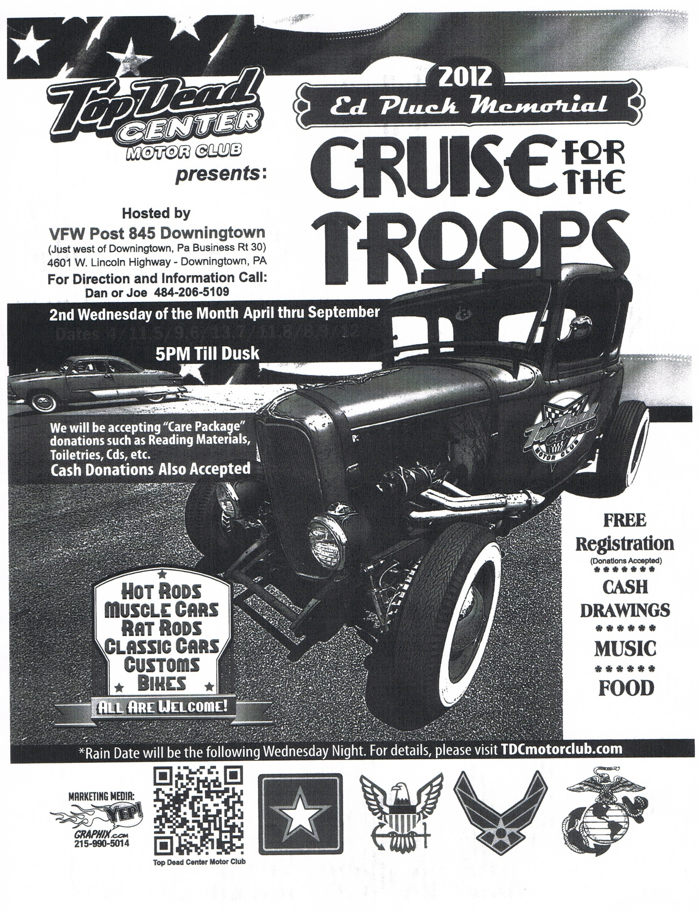

***\*\*LAST SHOW OF THE SEASON - COME OUT AND SHOW YOUR SUPPORT***

**Classifieds:**

If you have an item that you would like to sell, or a specific item you are looking for you can submit it for the newsletter and